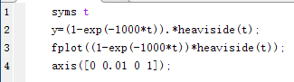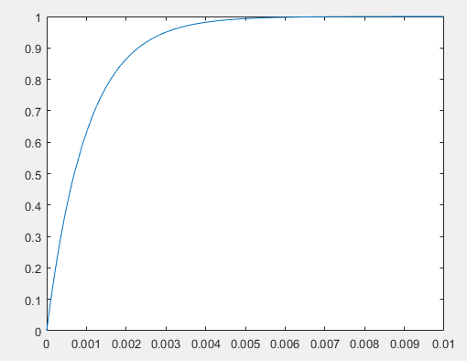4.1 (b)

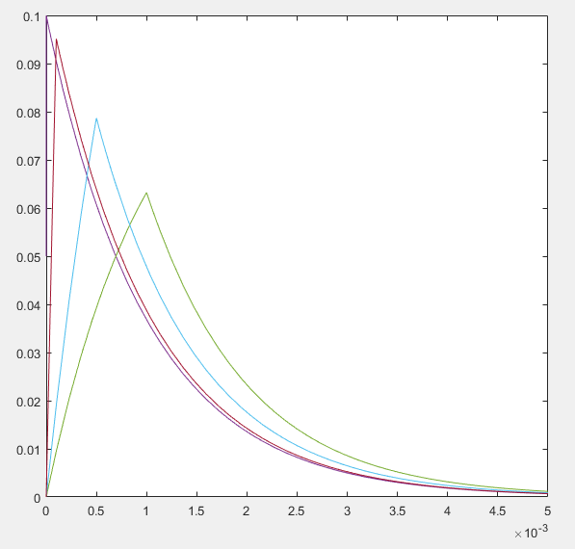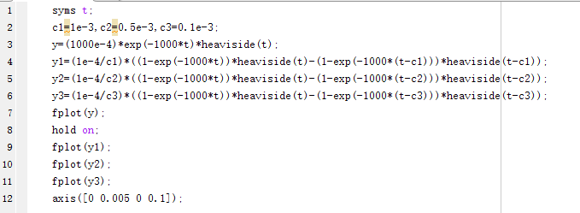4.3 (c)

4.6

|  |  |  |  |  |  |
| --- | --- | --- | --- | --- | --- |
| fc | 50Hz | 200Hz | 500Hz | 1kHz | 5kHz |
| |H(j2πfc)| | 0.9540 | 0.6227 | 0.3033 | 0.1572 | 0.3181 |
| ∠H(j2πfc)(o) | -17.4496 | -51.4881 | -72.3432 | -80.9569 | -88.1768 |
| τd(j2πfc) (ms) | 0.9689 | 0.7151 | 0.4019 | 0.2249 | 0.04899 |